**H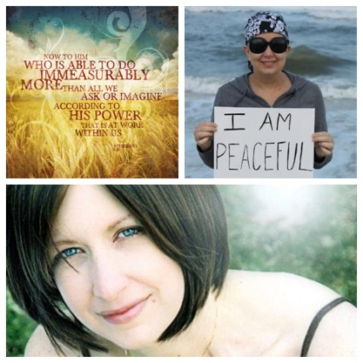UNT** 

**To Whom It May Concern,** August 18, 2013

We are hosting the first annual **Hunt for Hope Vero** on Saturday, September 28, 2013 from 12:30 pm – 4 pm in the Vero Beach area with our local chair Dr. Holly Hamilton and the team of Treasure Coast Family Dental. We respectfully request your support. We are requesting a sponsorship donation or simply a sponsorship token through an item that would be included in our event for raffle prizes or team awards. Your donations will be listed on our website and Facebook as a valued sponsor. This is the first Hunt for Hope in Florida and your sponsorship will create strong community awareness and will directly support our cause in raising money that will be **100%** donated to Inflammatory Breast Cancer research.

**What is Hunt for Hope?**

Hunt for Hope is an old fashioned scavenger hunt! Hunters will be given a list of items to find and tasks to complete. (NEED digital camera or camera phone.) All funding raised from Hunt for Hope Vero will underwrite IBC research via The IBC Network Foundation. [www.theibcnetwork.org](http://www.theibcnetwork.org) Dr. Lori Grennan led the Ohio Hunt for Hope for the past two years while battling IBC breast cancer. Lori and Ohio directly raised over $100,000 over the course of these two events. Tragically, we lost Lori this year, but our hope is to continue her heralded effort and raise enough donations in her honor to directly fund IBC breast cancer clinical research. Hunts for 2013 are currently on the calendar for Vero Beach, Ohio, and two in Texas. Lori was a personal friend and affected so many people with her fight. She was diagnosed at 32 years old and because it usually presents in younger women (and men), and it doesn’t normally present as a lump that can be detected in a mammogram, it is imperative that we are educated to know about it and what to look for.

**What is IBC?**

Inflammatory breast cancer is a rare but most fatal form of breast cancer. While it accounts for 2-6% of all breast cancers, the 5-year overall survival rate is 30%, as compared to near 90% for all types of breast cancer combined. Since IBC cannot be detected until stage III, we need more research for this aggressive form.

**Want to see what The IBC Network has funded?**

We are a fairly new charity, (501c3 EIN # 38-3850833) only formed in the fall of 2011, but we have already funded two projects. Our first project was a clinical trial under the direction of Dr. Wendy Woodward at MD Anderson Cancer Center in Houston, Texas. Our second project was under the direction of Dr. Ueno who studied the effects of statins, a drug used in IBC patients. Lori Grennan was instrumental in establishing this foundation and because of a lot of her tireless work, even in the face of her own diagnosis, we are able to continue her vision in helping to fund studies for this very aggressive form of breast cancer. You can read more on our website at [www.huntforhopevero.weebly.com](http://www.huntforhopevero.weebly.com) or find our event on Facebook by searching “Hunt for Hope Vero” under events. We are truly grateful for anything you are able to help us with in establishing this annual event in our own community.

Humbly yours,

Holly Hamilton, DMD

